 Habib University
EE-437 Renewable energy systems – Fall 2025

Time = 15 minutes | Quiz 03 | Max Points: 20

CLO 1 - 20 marks
Question 1 [2 points]: Define pitch and yaw control for a wind turbine.
Pitch: Adjustment of blade angle relative to wind
Yaw: Rotation of the entire nacelle around the vertical axis to face the wind.
Question 2 [2 points]: Give general differences between onshore and offshore wind farms.
Onshore | Offshore
Built on land | Built on water
Weaker winds therefore less energy production | Stronger winds therefore produce more energy
Cheaper to install and maintain | More expensive to install and maintain
Less socially acceptable | More socially acceptable

Question 3 [1 point]: Describe wake expansion.
Wake expansion is the gradual widening of the slower, turbulent airflow behind a wind turbine as it mixes with the faster surrounding air. This mixing causes the wake to spread and the wind speed to recover farther downstream.
Question 4 [2 points]: Sketch the graph for pressure and wind speed before and after wind turbine.
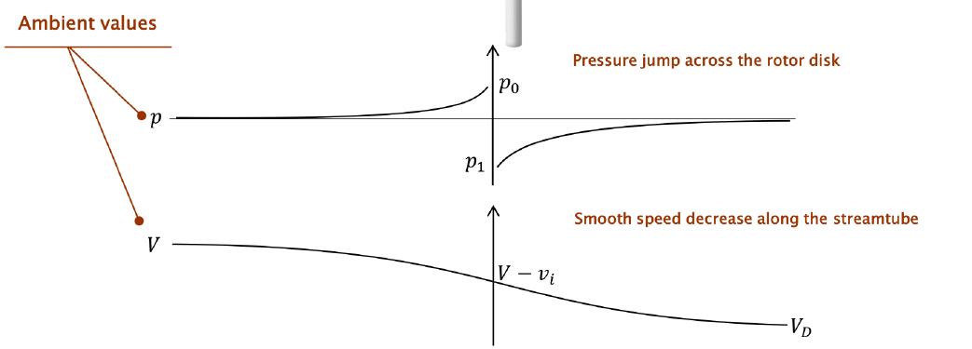
Question 5 [2 points]: What is the value for the maximum value of $C_{P}$ and for what value of a is it achieved?
$${Max C}_{P}=0.59 at a=\frac{1}{3}$$

Question 6 [2 points]: What is the formula for Tip speed ratio?
$$TSR=\frac{ΩR}{V}$$
Question 7 [2 point]: Sketch the graph for power vs wind speed for a typical wind turbine. Make sure to mark $V_{cutin}$ , $V_{r}$ and $V_{cutoff}$
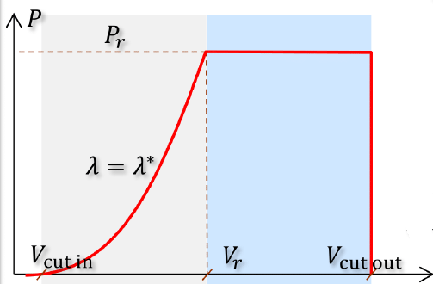
Question 8 [3 points]: What are the four distinct regions in the power vs speed graph?
Region 1: V< Vcut in : No energy production
Region 2: Vcut in < V < Vr : Constant TSR strategy
Region 3: Vr < V < V cutout: Constant power
Region 4: V> Cutout : No energy production
Question 9 [2 points]: Sketch the graph for Weibull distribution. In what way is the biggest difference between this distribution and typical distribution for wind in a specific region?
Main difference is that Weibull distribution has low probability at the 0 wind speed mark, which is not true in most cases.
Question 10 [2 points]: Why do we find wind turbines away from cities unlike solar panels?
Turbines are large and cannot be easily installed in cities and roofs unlike solar panels.
Turbines produce significant noise and vibrations.
Wind speeds are better away from cities.

